FORM 2: NOTICE OF ELECTION AND CALL FOR NOMINATIONS

An election is to be conducted for members of the school council of Cobram Secondary College

Nomination forms may be obtained from the school and must be lodged by 4.00 pm on:

…03.../……03…./.…2026……. (insert day, month and year).

The ballot will close at 4.00 pm on:

…12……./….03……./…2026……. (insert day, month and year).

Following the closing of nominations a list of the nominations received will be posted at the school.

The terms of office, membership categories and number of positions in each membership category open for election are as follows:

MEMBERSHIP CATEGORY | TERM OF OFFICE | NUMBER OF POSITIONS
Parent member  2 Year Vacancy | From the day after the date of the declaration of the poll in 2026 to and inclusive of the date of the declaration of poll in 2028 | 3
School employee member  2 Year Vacancy | From the day after the date of the declaration of the poll in 2026 to and inclusive of the date of the declaration of poll in 2028 | 2
Student member | From the day after the date of the declaration of the poll in 2026 to and inclusive of the date of the declaration of poll in 2028 | 2

If the number of nominations is less than the number of vacancies, a notice to that effect and calling for further nominations will be posted in a prominent position at the school.
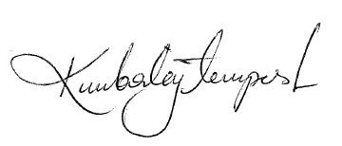
Kimberley Tempest
Principal

